Sepro Robotique
Rue Henry Bessemer, Zone Acti-Est
CS 10084 -85003 La Roche-sur-Yon
France
Phone: +33 2 51454700
PRESS INFORMATION

February 4, 2021

CONTACT: Caroline Chamard, Sepro Group - France, +33 (2) 51 45 46 37; cchamard@sepro-group.com Scott Collins, Public Relations, +1.216.382.8840; scollins@collins-marcom.com

Sepro Group Names Charles de Forges New CEO

Charles de Forges brings almost 20 years of experience in senior management roles at business-to-business companies to his new position as the executive head of Sepro Group, the robot and automation supplier headquartered in La Roche-sur-Yon, France.

“We took our time in finding our new CEO,” said, Eric Radat, President of Sepro Group, “but, in Charles de Forges, we have found the right person to help guide Sepro into the future. He has a dynamic personality, and he is very customer-focused. He has experience in managing businesses both large and small, and he understands the special nature of a family-owned business like Sepro. He also has an entrepreneurial spirit, having started his own 3D printing company, so he knows what it is to dare and overcome challenges. In short, I trust his leadership.

With a graduate degree in Mechanical Engineering degree, de Forges has gained a wide business experience in industry in sectors such as packaging, luxury, cosmetics, automotive and aerospace and has worked internationally in Europe, the USA and Brazil.

“Sepro is a fantastic example of a family owned company, proud of its regional roots while being a world leader in robots and automation,” de Forges stated. “I am very happy to join a company full of exciting projects, along with a dynamic and ambitious team. I am looking forward to taking part in the future of this company and to make it grow even further as a robotics leader.”

About Sepro

Sepro was one of the first companies in the world to develop Cartesian beam robots for injection-molding machines, introducing its first CNC controlled “manipulator” in 1981. Today, Sepro Group is one of the largest independent sellers of robots in the world, offering a wider choice of robots than any supplier in the plastics industry. Three-, five-, and six-axis servo robots; special-purpose units; and complete automation systems, are all supported by the Visual control platform developed by Sepro especially for injection molders. This unique controller is a key component in what the company refers to as ‘open integration’ – a collaborative approach to equipment connectivity and interoperability that can be tailored to exactly suit the specific needs of processors and injection-molding OEMs. At Sepro, customers “Experience Full Control.”

XXX
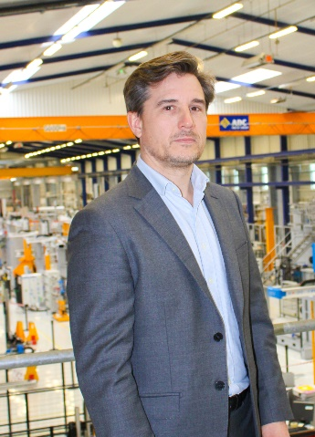
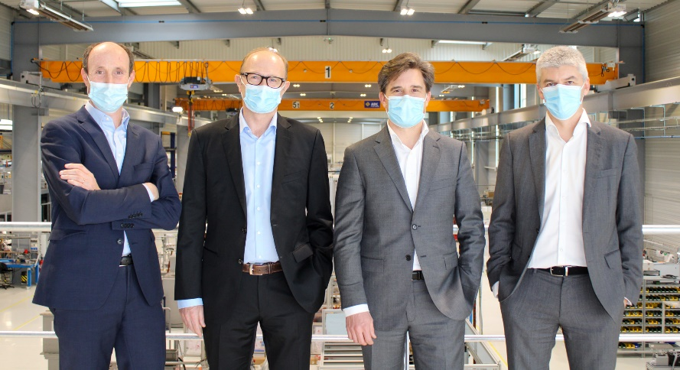
Sepro Group leadership: (left to right) Nicolas Préfol, Chief Financial Officer, Eric Radat, President, Charles de Forges, Chief Executive Officer, and Xavier Lucas, Chief Sales Officer.

Link to high-resolution photo: http://www.collins-marcom.com/wp-content/uploads/CP-new-CEO-2.jpg
Charles de Forges, CEO Sepro Group

Link to high resolution photo: http://www.collins-marcom.com/wp-content/uploads/Charles-de-Forges-3.jpg

