Sepro Robotique
Rue Henry Bessemer, Zone Acti-Est
CS 10084 -85003 La Roche-sur-Yon
France
Phone: +33 2 51454700
PRESS INFORMATION

13 June 2017

CONTACT: Caroline Chamard, Sepro Group - France, +33 (2).51.45.46.37; cchamard@sepro-group.com
Scott Collins, Public Relations, +1.216.382.8840; scollins@collins-marcom.com

New Success 5 Robot from Sepro
Offers Big Performance on Small IMMs

The Success 5, the newest and smallest in Sepro Group’s range of economical, general-purpose Cartesian robots for plastics injection molding, delivers precise, 3-axis servo performance in simple pick-and-place and stacking applications.

First announced in late 2016 (along with the S5 Picker, which shares a similar mechanical design), the Success 5 is now available to equip injection-molding machines up to 80 tons. Like all Sepro Success robots, it is equipped with a standard R1 pneumatic (0° - 90°) rotation, but offers an optional R3 rotation (0° - 90° or 0° - 180°).

The standard Success 5 can be configured with horizontal strokes of 1000 or 1500 mm, a 400-mm demolding stroke, a 1000-mm vertical stroke and a 3-kg maximum payload. Other standard features, normally available only on more expensive robots, include:
- Simultaneous motion on all three axes;
- ‘Y-free’ function, which makes it easier to program ejection tracking and saves on gripper costs thanks to its simple design;
- Multiple vacuum and pressure circuits to allow degating, selective part placement and other functions;
- Quick disconnects for fast end-of-arm tooling changeovers;

Standard equipment for the Success 5 also includes Sepro’s Touch 2 control, which features a touch screen and ultra-simple, icon-driven instructions that enable even inexperienced operators to create basic pick-and-place robot cycles. Easy-to-follow on-screen prompts lead the user through the execution of the robot cycle, teaching all relevant robot positions as part of the cycle-development process.
The S5 picker, which was introduced at the K 2016 show in October, is built around the same compact 3-axis linear design as the Success 5 robot, but features a simple sprue gripper. The S5 picker can be supplied optionally with an R1 wrist rotation and can be fitted with simple end-of-arm tooling. This compact, fast-cycling picker operates entirely within the footprint of the injection molding machine or, optionally, can be configured to evacuate sprues or small parts outside the IMM footprint.

SUCCESS 5 SPECIFICATIONS
Mold Clamping Force (Metric Tons) | 20-80
Horizontal Stroke (mm) | 1000-1500
Max. Instantaneous Speed – Horizontal (m/sec) | 2
Strip Stroke (mm) | 400
Max. Instantaneous Speed – Strip (m/s) | 2
Direct Vertical Arm | ✓
Vertical stroke (mm) | 1000
Max. Instantaneous Speed – Vertical (m/s) | 3
Max. Load – Parts & EOAT (kg) | 3
R1 Pneumatic Rotation (0-90°) | ✓
Part gripping -- Vacuum and/or pressure circuit | 1
Compact Beam-Mounted Control Cabinet | ✓
Touch 2 control (Visual 2, option) | ✓
R3 Pneumatic Rotation (0-90-180°) | Option

About Sepro
Sepro was one of the first companies in the world to develop Cartesian beam robots for injection-molding machines, introducing its first CNC controlled “manipulator” in 1981. Today, having equipped more than 30,000 injection-molding machines, Sepro Group is one of the largest sellers of robots in the world. Its 3-, 5- and 6-axis servo robots, special-purpose units and complete automation systems, are all supported by the Visual control platform developed by Sepro especially for injection molders. This unique controller is a key component in what the company refers to as ‘agile integration’ – a collaborative approach to equipment connectivity and interoperability between the robot and the IMM that can be tailored to exactly suit the specific needs of processors and injection-molding OEMs. For Sepro and its customers and partners, “The Future is Wide Open.”
XXX

See photo on next page…
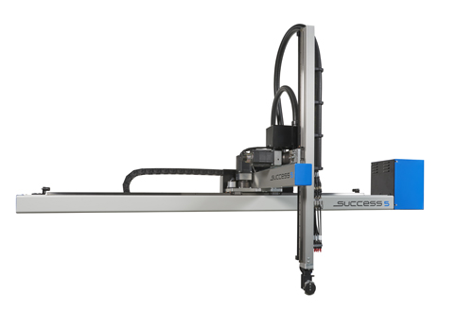
The new Success 5, the smallest in Sepro’s Success line of general-purpose robots, offers precise, 3-axis servo performance on injection molding machines from 20 to 80 tons.
Download a high-resolution file at: http://tinyurl.com/kpcp7tp

